
PRESS RELEASE Prague, 14 November 2018

ALPHA Building in BB Centrum is fully occupied

Frequentis, a significant tenant of the ALPHA Building in Prague’s BB Centrum, has expanded and thereby filled the last available square metres of space in this office project. ALPHA, built in 2003 according to a design by the architecture atelier Aulík Fišer architekti, underwent the reconstruction of primarily the interiors and the rooftop terrace in 2016. In addition to Frequentis, its permanent tenants include ČEZ, Xerox and Gorenje. BB Centrum is currently offering the last smaller office spaces in Building D and in the BETA and FILADELFIE buildings. In the first quarter of 2020, a further 14,500 m² off office space will also be available in the completely reconstructed Building B.

ALPHA has a total of 11,000 m² of office space on 8 storeys and 400 m² of retail units on the ground floor of the building, where a cafeteria, PuzzlePasta restaurant and Hájek & Hájková confectionary are open for the public and for tenants. Cultural events have been held in the building lobby since its reconstruction, with the last such event being the Mystery of Glass exhibit.

BB Centrum has long been one of the most sought-after localities, not only for Czech and foreign companies, but also for the inhabitants of Prague 4. This is primarily thanks to the wide variety of restaurants, cafes, playgrounds and cultural and social events. This year the multifunctional complex is celebrating the 20th anniversary from the construction of the first project, Building C.

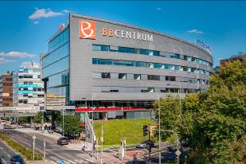

ALPHA Building in BB Centrum

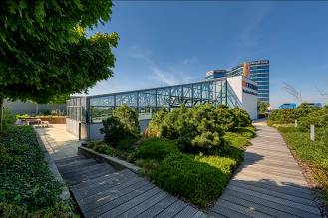

Reconstructed terrace of ALPHA Building in BB Centrum

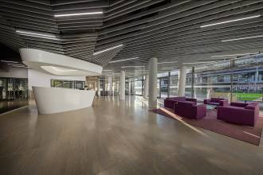

New lobby of ALPHA building with reception and possibility for holding cultural events

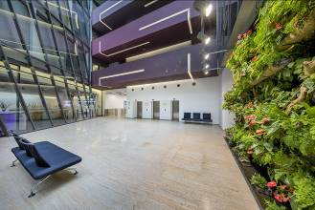

Green wall in ALPHA building

You can get more information and photographs in print quality from:
Kristýna Samková, Head of PR and Marketing Department
PASSERINVEST GROUP, a.s.
Tel.: (+420) 221 582 111
Mobile: (+420) 602 186 708
E-mail: kristyna.samkova@passerinvest.cz
www.passerinvest.cz, www.bbcentrum.cz

Marcela Štefcová
Crest Communications a.s.
Mobile: (+420) 731 613 669
E-mail: marcela.stefcova@crestcom.cz

About the developer

PASSERINVEST GROUP, a. s., is a purely Czech development and investment company, whose name is primarily connected with the realisation of the multifunctional BB Centrum complex in Prague 4 – Michle. The company, established by Radim Passer in 1991, built a very good reputation both on a local and international level with this, the most successful and extensive project of its kind in Central Europe. This is not only to the credit of the quality of the realised projects and the high level of the provided services, but also due to the sense of fair play, an accommodating relationship with the buildings’ tenants/users and responsibility to the society and the environment. PASSERINVEST GROUP also has other interesting development projects in its portfolio.

